Chapter

Fruit

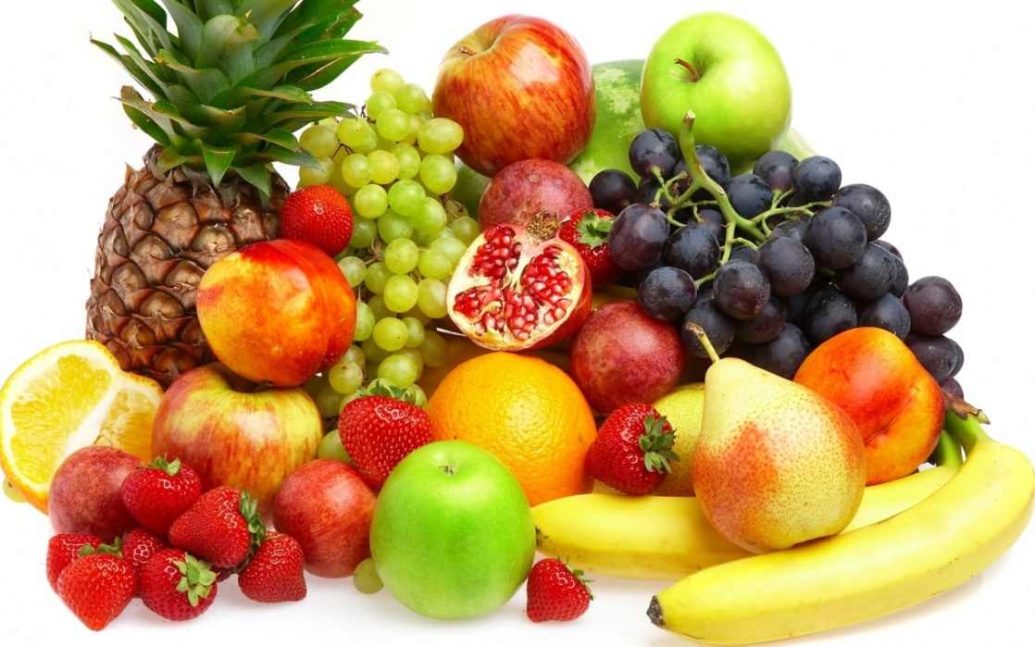

Mature fertilized ovary is called fruit; it is developed from the gynoecium. It results from the maturation and ripened of one or more ovary, and may include other parts of the flower. It is the vital part of plant.

Main features of a fruit

- It is the fertilized and mature ovary
- May compose of one or more carpel
- It may contains other parts of ovary
- Fruit is also produced without fertilization which is known as perthenocarpic fruit

Function of fruit

- Fruit protect seeds and helps in dissemination
- Supply nutrients to the seed
- May be the factor of timing of germination.

A fruit consists of two parts namely pericarp and seed. The pericarp is developed from the wall of ovary and the seeds are produced from the ovule. In case of fleshy fruit, the pericarp may be composed of epicarp, mesocarp and endocarp.

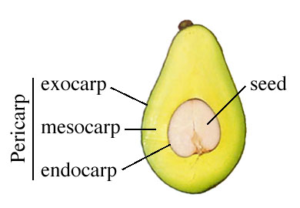

Types of fruit

Generally fruits may be classified based on the following criteria:

- The type of flower from where fruit is produced
- Number of ovaries of flower involve in the fruit development
- The number of carpels/pistil in each ovary
- The nature of mature pericarp(dry or fleshy)
- Whether the pericarp splits (dehisces) at maturity
- If dehiscent, the manner of splitting
- The possible role that sepals or receptacle may play in formation of the mature fruit

Fruits may be dried and fleshy based on the moisture content on the ovary, and which can be classified as dry and fleshy fruit.

True fruit

When the ovary is converted into fruit some time the accessory whorl contributed in the formation of fruit.

False fruit (Pseudo-carp)
When other whorl except the ovary i.e. thalamus is converted into fruit.

- Thalamus is converted into fruit e.g. apple
- Pedicel is converted into fruit e.g. cashewnut
- Calyx is converted into fruit e.g. Dellenia

Parthenocarpic fruit: Development of fruit without fertilization e.g. banana, orange

Simple fruit

Simple fruit is formed from a single ovary having monocarpellary or polycarpellary syncarpous ovary without any accessory part. e.g. mango, litchi etc.

Characteristics of simple fruit

- Number of carpel is one i.e. monocarpellary
- Carpel number may be more than one but they are united i.e. syncarpous of polycarpellary

Simple fruits are two types’ viz. dry simple fruit and fleshy simple fruit

Dry simple fruit

Characteristics of dry simple fruit

Fruit wall or pericarp is dry

Types of dry simple fruit:

- Achenial fruits
- Schizocarpic fruit
- Capsular fruit

- Achenial fruits

Develop from monocarpellary or polycarpellaysyncarpous pistil having single ovule. The fruit possesses a single seed and does not dehiscent. The achenial fruits are following types:

- Achene

A dry, mono-carpellary one seeded fruit developing from a superior monocarpellary ovary where pericarp is free from the seed coat e.g. sunflower

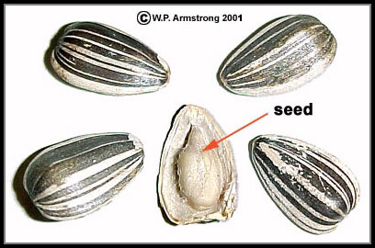

- Caryopsis/grain

A dry, one chambered and one seeded fruit developing from a superior monocarpellary where pericarp is fused with the seed. It is the characteristic feature of Poaceae (Gramineae) family which includes such important plants as wheat, corn and rice.
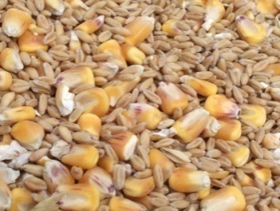

- Cypsela

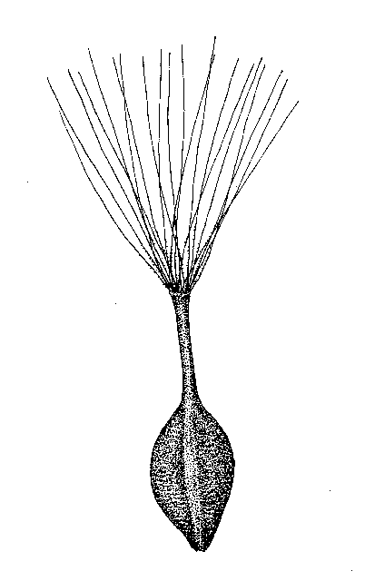
It is dry, single- seeded fruit developed from the inferior ovary of bicarpel where the pericarp and seed coat are free e.g. sunflower.

- Nut

It is dry, one chambered, one seeded fruit developed from a superior ovary of bicarpel where the pericarp is hard and woody e.g. chestnut.

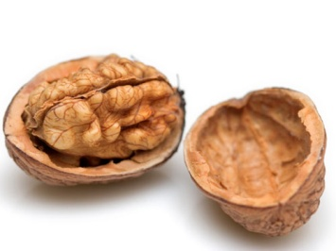

- Samara

A samara is a winged achene, a type of fruit in which a flattened wing of fibrous, papery tissue develops from the ovary wall. A samara is a simple dry fruit and indehiscent (not opening along a seam).

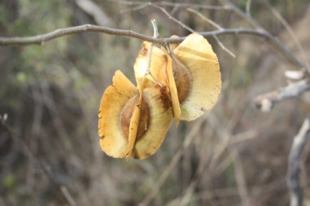

Schizocarpic fruit

- Dry fruit
- Many seeded
- Indehiscent

The schizocarp is a dry fruit consisting of two carpels that split, when mature, along the midline into two one-seeded indehiscent halves e.g.

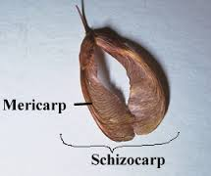

Types of Schizocarpic Fruit

- Double summara-consist of more than one samara e.g. Sapindaceae

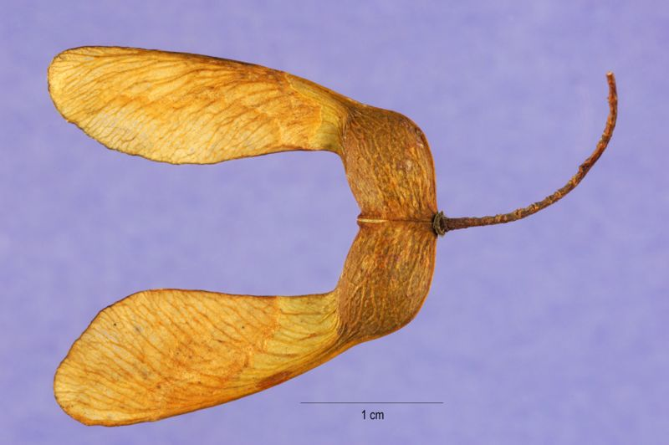

- Cremocarp-a dry indehiscent double chambered fruit developed from inferior ovary e.g. coriander

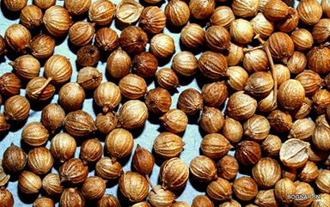

- Lomentum- legume is constricted or partitioned between the seeds into a number of one seeded parts e.g. Acacia.

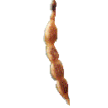

- Utricle-One seeded fruit with a thin bladdery, persistent, sometimes inflated wall e.g. found in some amaranths.

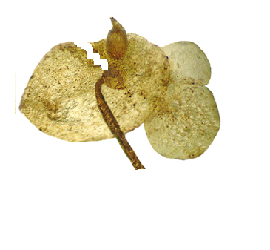

Capsular Fruit

- Dry fruit
- Dehiscent
- Many seeded
- Develop from a simple or compound superior ovary

Legume or pod
A dry monocarpellary fruit develops from a superior one chambered and dehiscenting both sutures e. g. pea. It is the characteristic feature of the family Fabaceae (Legumonosae).

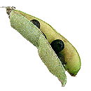

Follicle
It is similar to legume but dehiscent in one suture e.g. fruit of magnolia.
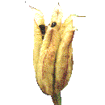

Capsule

A many-seeded, unicarpellary or polycarpellary fruit develops from a superior ovary where the fruit is dehiscent in many ways e.g. jute, cotton etc.
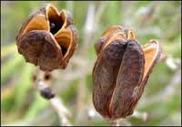

Siliqua

A long many seeded fruit developing from a superior, bicarpellary ovary with dehischscenting from below upwards by both the sutures e.g. Brassica

Cremocarp

This is a dry indehiscent two chambered fruit which is developed from inferior ovary e.g. coriendar.
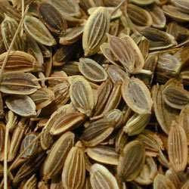

Fleshy Fruits

Characteristics

Pericarp and mesocarp are fleshy.

Drupe

A fleshy, one or more chambered and one or more seeded fruit developing from a monocarpellary or polycarpellary syncarpous pistil e.g. mango, peach, coconut, pulm. Here the pericarp is divided into three distinct parts e.g. epicarp, mesocarp and endocarp.

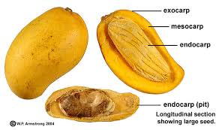

Berry

Berry is a simple fruit having seeds and pulp produced from a single ovary; the ovary can be inferior or superiore.g. banana, tomato, chili. The seeds are arranged scattered in the fruit.

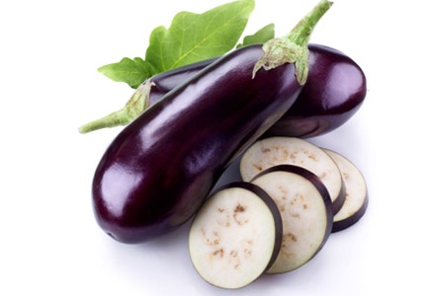

Pome/false fruit

An inferior, two or more-celled fleshy fruit surrounded by the thalamus e.g. apple, pear etc.

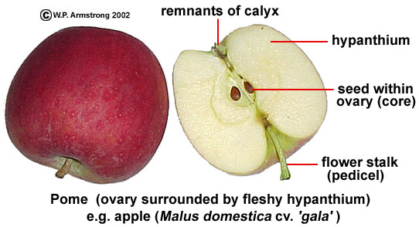

Hesperidium

Hesperidium is modified berries which have a leathery skin. In some cases, portions of the skin are edible, but it may not taste good e.g. citrus.

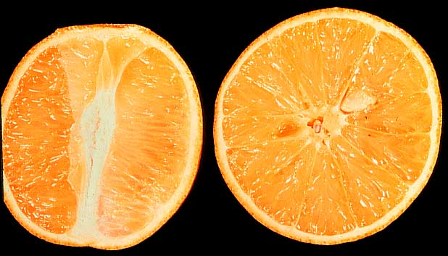

Pomegranate

The pomegranate, botanical name Punicagranatum, is a fruit-bearing deciduousshrub or small tree growing between 5 and 8 m (16–26 ft) tall.

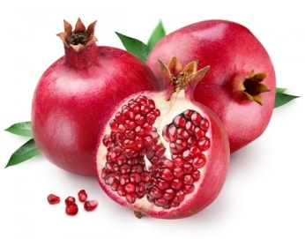

Pepo

This is a modified berry where the placentation is parietal e.g. water melon, cucumber etc.

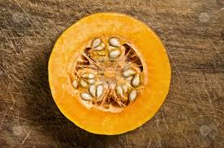

Compound fruit

Compound fruit or multiple fruits are formed from cluster of flowers or inflorescence. Each flower in the inflorescence produces a fruit, but these mature into a single mass e.g. Jackfruit, pineapple, mulberry, breadfruitetc. The compound fruits are two types’ viz. Syconus and Sorosis.

Syconus

Syconus is a special type of multiple/compound fruit which is formed by an enlarged, fleshy, hollow receptacle with multiple ovaries on the inside surface. It is developed from the inflorescence of hypanthodium e.g. banyan,pipul etc.

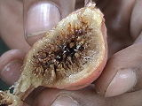

Sorosis

If the entire inflorescence develops into a fruit, it is known as a multiple or composite fruit. It is developed from the inflorescence of spike or spadix where flowers are fused together and the whole inflorescence is converted into a single fruit e.g. jackfruit, pineapple, mulberry etc.
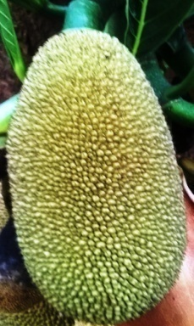
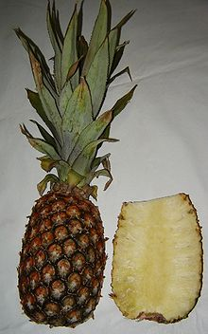

Aggregate fruit

An aggregate fruit or etaerio or etario is a fruit that develops from the merger of several ovaries that were separate in a single flower e.g.custard apple, bullock heart etc.

